**Lab 6**

2023101124 – Goni Anagha Room Number -- 125

2023101120 – Sachi Thonse Rao Table Number -- 43

**Aim:**

1A) Using a PIR motion sensor to detect motion and updating the info on a webpage using the server approach.

1B) To operate the PIR motion sensor in the multiple trigger mode and incrementing a counter on the webpage when the motion is detected.

2) Lighting up an LED through a webpage using client approach.

**Hardware picture:**

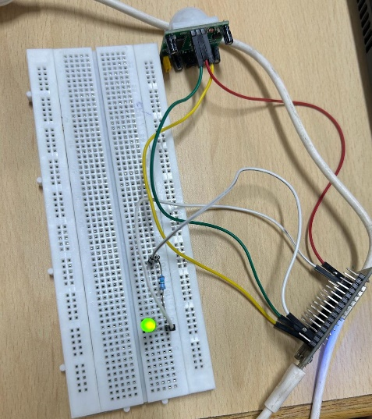 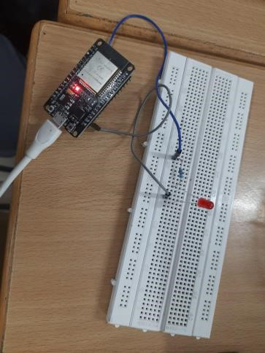

**Observations:**

1A) We observe that when motion is detected the PIR motion sensor gives digital output i.e., either ‘1’ (motion detected) or ‘0’ (motion not detected) and calibration of sensor is 3m to 7m. Because of its large range of detection it detects any small motion within that range. We also observe that the sensor which is working currently in single trigger mode triggers LED to simultaneously switch on and switch off as long as the motion is detected i.e, output of the sensor is continuously triggered between 1 and 0 even if the object motion is detected continuously.

1B) In continuation to above part, we test the sensor in multiple trigger mode. We observe that in multiple trigger mode, sensor output stays high as long as object motion is detected and once object is halted output stays high for some specified delay and becomes ‘0’.

2) In this part of the experiment, we used client approach i.e., client decides whether to switch on the LED or switch off the LED through a html page where the client can make choice. We observed that Wi-Fi library of ESP32 can be used to perform an operation through html page.

**Challenges faced during the experiment:**

We faced challenge in 2nd experiment where we are working with sensor in multiple trigger mode. Output was correct but the code was giving wrong count of number of motions detected. It should increase only one count for every continuous motion i.e., once the motion starts count should increase by 1 and it should increase again only when the sensor goes to high after going low in multiple trigger mode (when object is halted and then starts) but writing code for this was little bit challenging to us.

**Conclusion:**

We tested the working of a PIR (Passive Infrared Sensor) in both its modes which are single trigger and multiple trigger. Single trigger mode was used for detecting the presence of motion while multiple trigger mode was used to count the number of times motion was detected. The output of both the experiments were displayed on a webpage using the Wifi and Webserver libraries. The last experiment allowed us to control the blinking of an LED through two links on a webpage. If the user clicked on the glow led link, the LED switched on and vice versa. Through these experiments, we can come to the conclusion that a PIR sensor can be used as a motion detector which can further be utilised to trigger some other reaction.